Core concepts :-

Alert

1. Cypress auto accepts alerts
2. Cypress have capability of browser events “window.alert” this Is event which is get fired from alert event. So we are fireng event by cypress and capturing alert text.

Child window

1. Cypress cannot handle multiple window multiple tab , so approach is , remove target attribute from element and click on element.

 cy.get("#opentab").invoke("removeAttr","target").click()

when you moved to new domain cypress cannot handle it you have to tell cypress by calling origin and inside that you have to give operation you want to perform on that domain

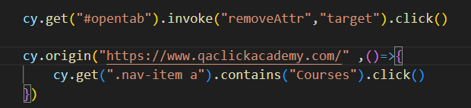

To iterate through table we have to use Each

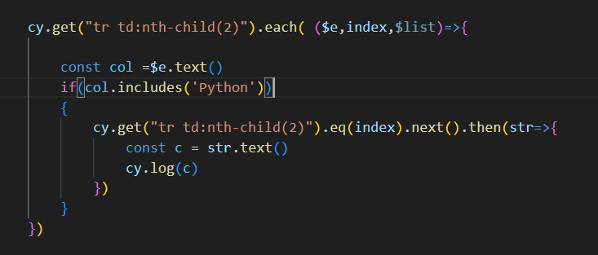

Mocha awesome reporter

1. Open <https://www.npmjs.com/package/cypress-mochawesome-reporter/>

npm i --save-dev cypress-mochawesome-reporter

1. Add Reporter in cypress.config file

reporter: 'cypress-mochawesome-reporter',

require('cypress-mochawesome-reporter/plugin')(on);

1. 